JBoss Installation And Configuration SOP For Division Rollout

Table of Contents

|  |  |  |
| --- | --- | --- |
| **Sl. No.** | **Description** | **Page No.** |
| 1 | Installation Instructions for JBOSS in UAT WEBA | 05 |
| 2 | Installation Instructions for JBOSS in UAT WEBB | 17 |
| 3 | Installation Instructions for JBOSS in UAT WEBX | 25 |
|  |  |  |
|  |  |  |
|  |  |  |
|  |  |  |
|  |  |  |
|  |  |  |
|  |  |  |
|  |  |  |
|  |  |  |
|  |  |  |
|  |  |  |
|  |  |  |
|  |  |  |
|  |  |  |
|  |  |  |
|  |  |  |
|  |  |  |
|  |  |  |
|  |  |  |
|  |  |  |
|  |  |  |
|  |  |  |
|  |  |  |
|  |  |  |

Document Information

|  |  |  |  |
| --- | --- | --- | --- |
| Project Name: | **LIC eFEAP Upgrade and Migrate** | | |
| Prepared By: | Mohanth Kumar Polakala | Document Version  No: | 1.0 |
| Title: | JBoss Installation And Configuration SOP For Division Rollout | Document Version  Date: | 1st Nov 2022 |
| Reviewed By: | Balakrishna Rakonda | Review Date: | 1st Nov 2022 |
| Approved By: |  | Approve Date: |  |

2

Document Version History

|  |  |  |  |  |
| --- | --- | --- | --- | --- |
| Version | Date | Prepared by | Description | File Name |
| Ver1 | 1st Nov OCT 2022 | IT Infra JBOSS Team | Initial Draft | JBoss_Installation_And_Configuration_SOP_For_Division_Rollout.docx |
|  |  |  |  |  |
|  |  |  |  |  |
|  |  |  |  |  |
|  |  |  |  |  |
|  |  |  |  |  |
|  |  |  |  |  |

Terminology and Acronyms

Following abbreviation have been used in this document

|  |  |
| --- | --- |
| Term | Definition |
| APP | Application |
| JBOSS | Java Beans Open Source Software |
| EAP | Enterprise Application Platform |
| CPU | Central Processing Unit |
| DB | Data Base |
| OEM | Original Equipment Manufacturer |
| OS | Operating System |
| RAM | Random Access Memory. Volatile memory available to an application for processing data and producing information. |
| SLA | Service Level Agreement |
| SQL | Sequential Query Language |
| TBD | To Be Determined |
| UAT | User Acceptance Testing |
|  |  |
|  |  |
|  |  |
|  |  |
|  |  |
|  |  |
|  |  |
|  |  |
|  |  |
|  |  |
|  |  |
|  |  |
|  |  |
|  |  |
|  |  |
|  |  |
|  |  |
|  |  |
|  |  |
|  |  |
|  |  |

Installation instructions for JBOSS in WEBA

root@Z99-XUN1-WEBA IP:10.194.50.131 (Master)

Login as root user

* [rootWEBA]# cd /opt**↵**
* [root@WEBA opt]# unzip jboss-eap-7.3.0.zip**↵**
* [root@WEBA opt]# chown -R feapadmin:feapadmin jboss-eap-7.3
* [root@WEBA bin]# chmod –R 755 /opt/jboss-eap-7.3 **↵**
* [root@WEBA bin]# su feapadmin
* [feapadmin@WEBA bin]$ cd /opt/jboss-eap-7.3/bin**↵**
* [feapadmin@WEBA bin]$ ./add-user.sh**↵**
* Press **a** for Management user
* Enter username as **efeap**

**If efeap is already exist then press “ a “ for update**

* Enter password as **efeap**
* Are you sure you want to use the password entered yes/no? – yes
* Re-enter Password **efeap**
* What groups do you want this user to belong to? – Press Enter
* Is this correct yes/no? – yes
* e.g. for a slave host controller connecting to the master – yes

**Changes in host-master.xml**

Path: /opt/jboss-eap-7.3/domain/configuration**↵**

Open the file: host-master.xml by using vim host-master.xml

Change IP address like as per below screen shot.

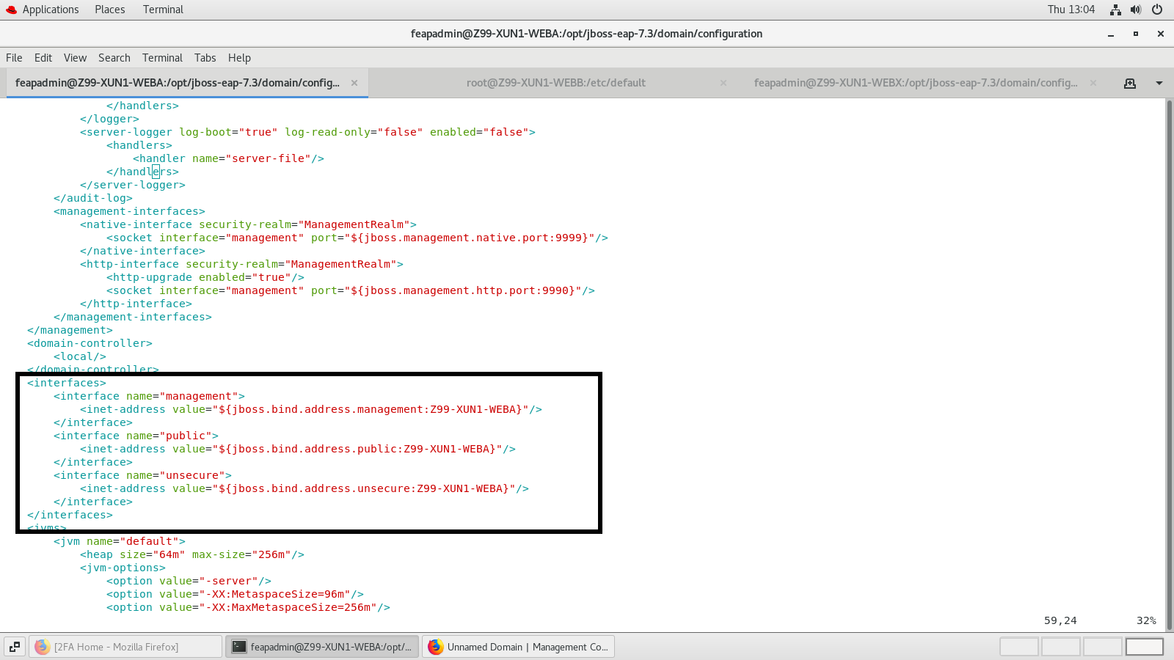

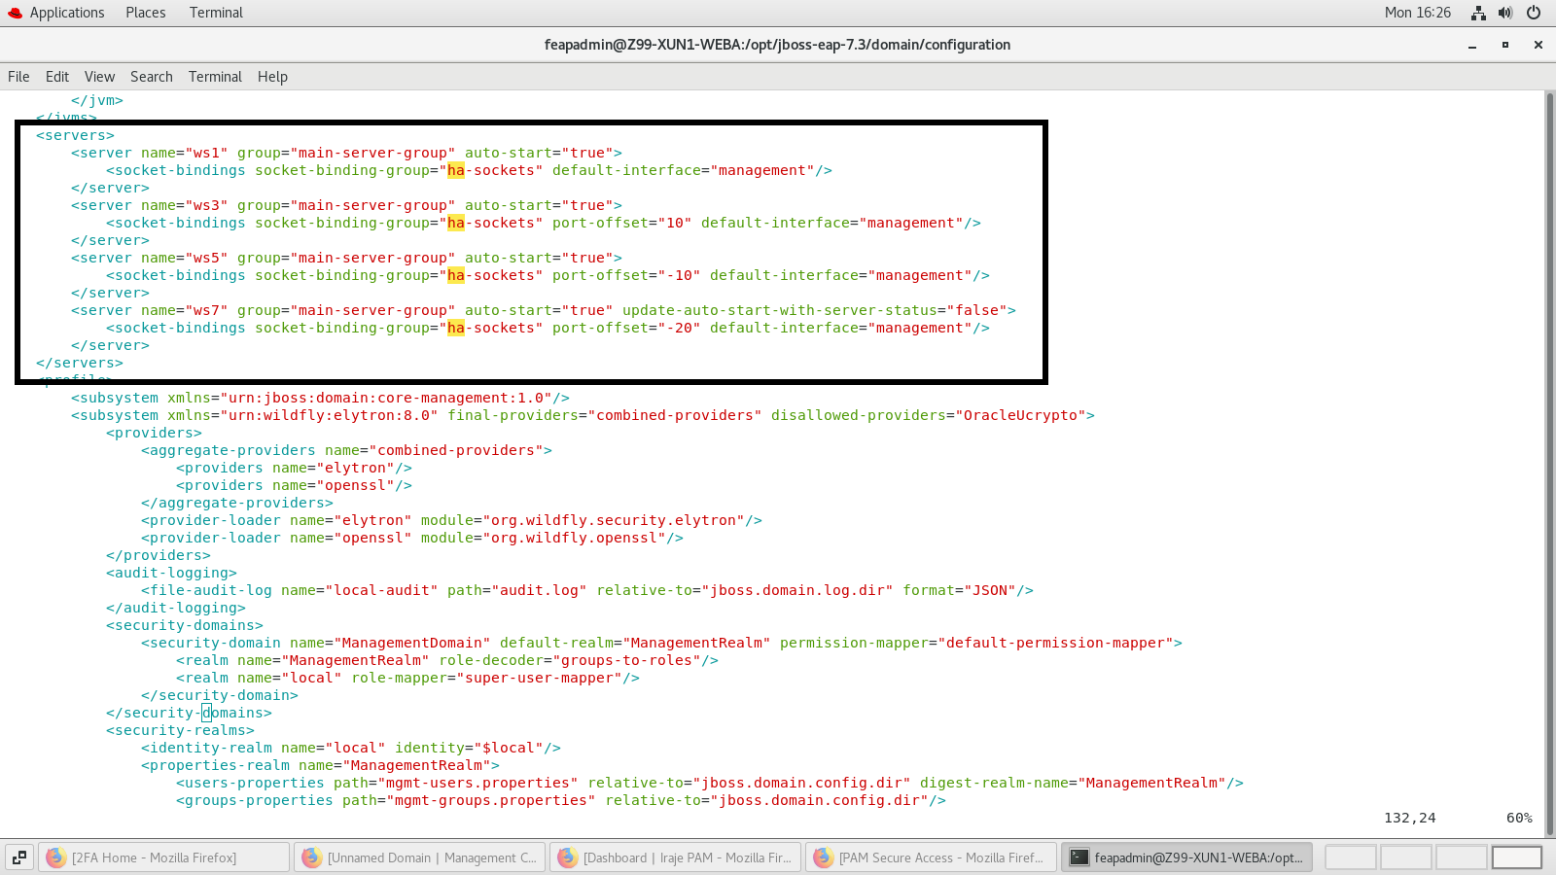

We have added below changes in domain.xml file under **ha** profile:

Path: /opt/jboss-eap-7.3/domain/configuration

File name: domain.xml

For more details find the screen shots below

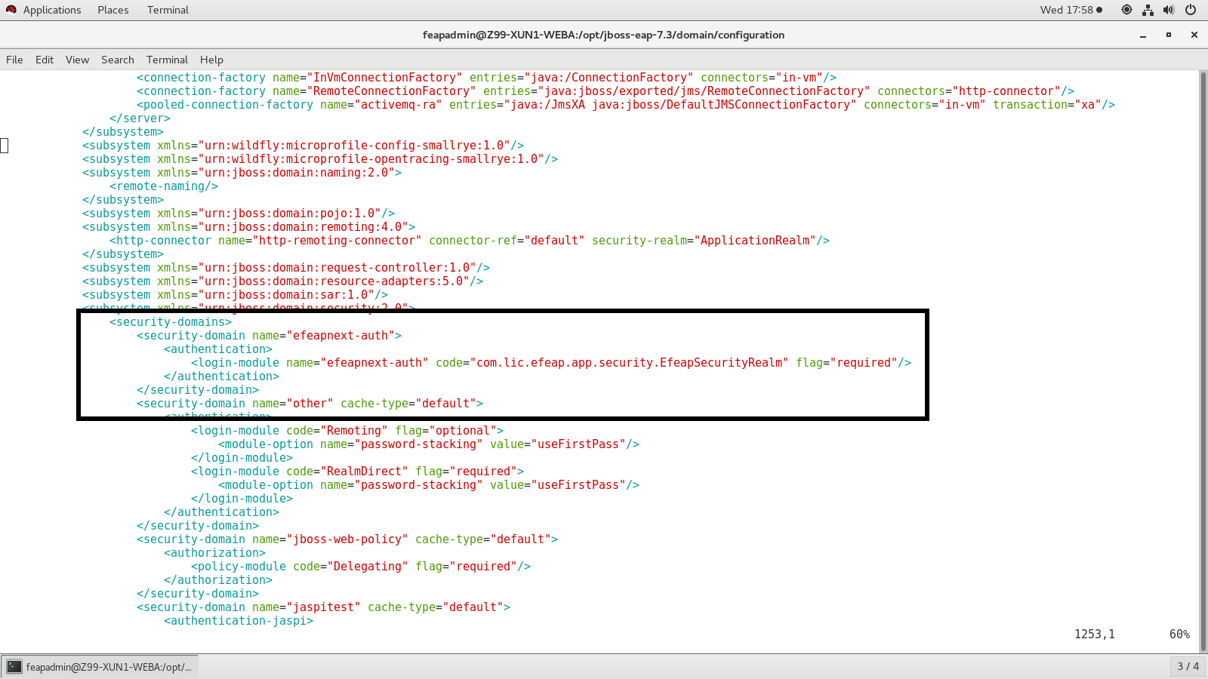

Add Heap size in domain.xml under server-groups like below:

Path: /opt/jboss-eap-7.3/domain/configuration

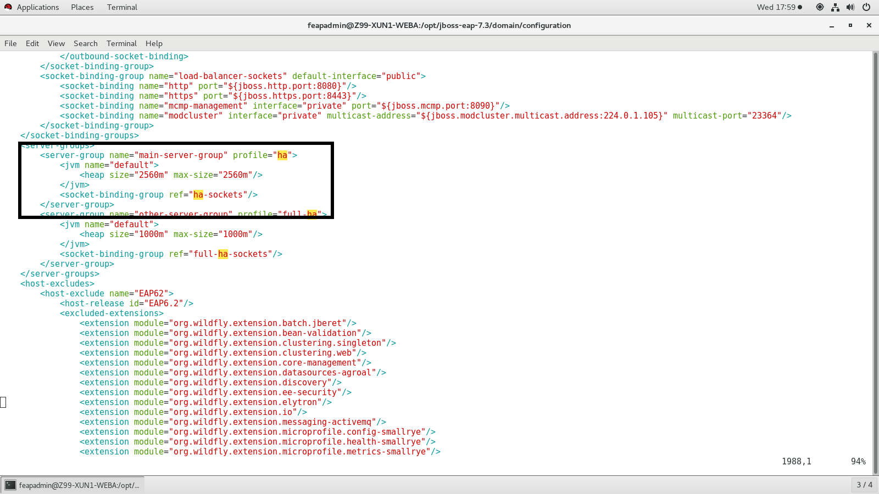

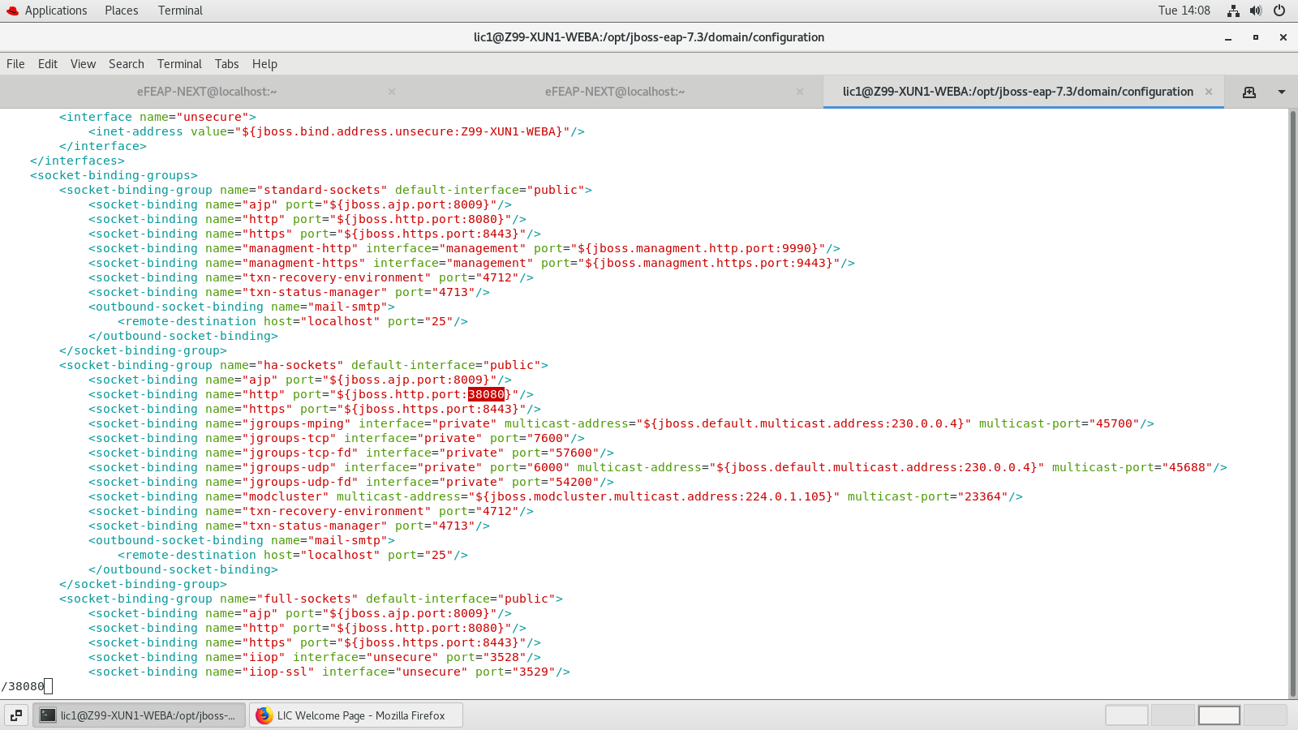

6. [feapadmin@WEBA ~]$ cd /opt/jboss-eap-7.3/bin**↵**

Find below changes in domain.conf file:

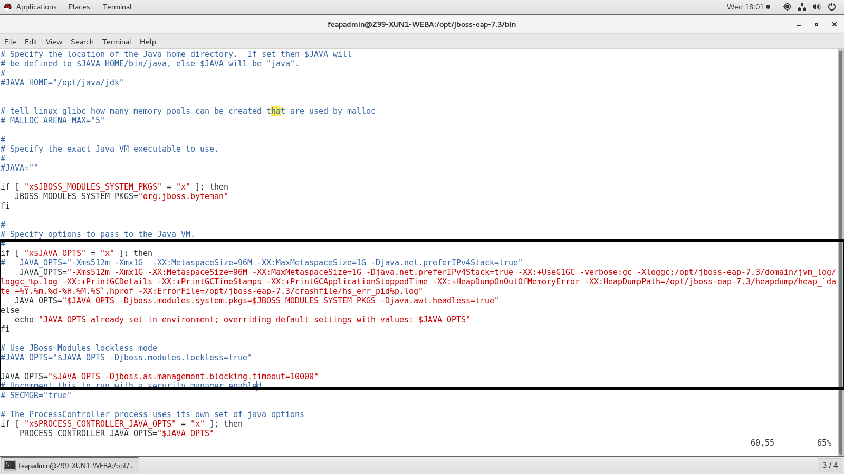

Path for gc log: /opt/jboss-eap-7.3/domain/jvm_log/loggc_%p.log

Path for heapdump: /opt/jboss-eap-7.3/heapdump/heap_`date +%Y.%m.%d-%H.%M.%S`.hprof

Path for crashfile log: /opt/jboss-eap-7.3/crashfile/hs_err_pid%p.log

**JBoss starting procedure find below:**

* [feapadmin@WEBA ~]$ cd /opt/jboss-eap-7.3/bin**↵**
* [feapadmin@WEBA bin]$ ./domain.sh --host-config=host-master.xml **↵**
* For Testing purpose Open Firefox and type in url http://10.194.50.131:9990/console/index.html
* Enter Username and password and click on Ok

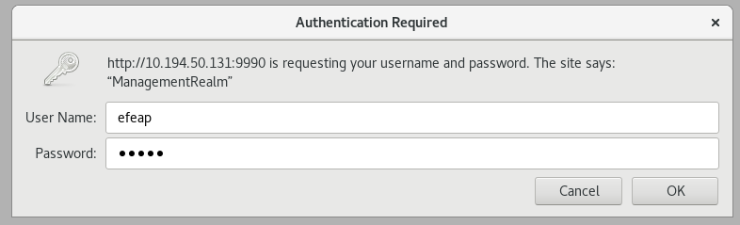

* Close firefox and stop the running jboss process through (**ctrl+c)**

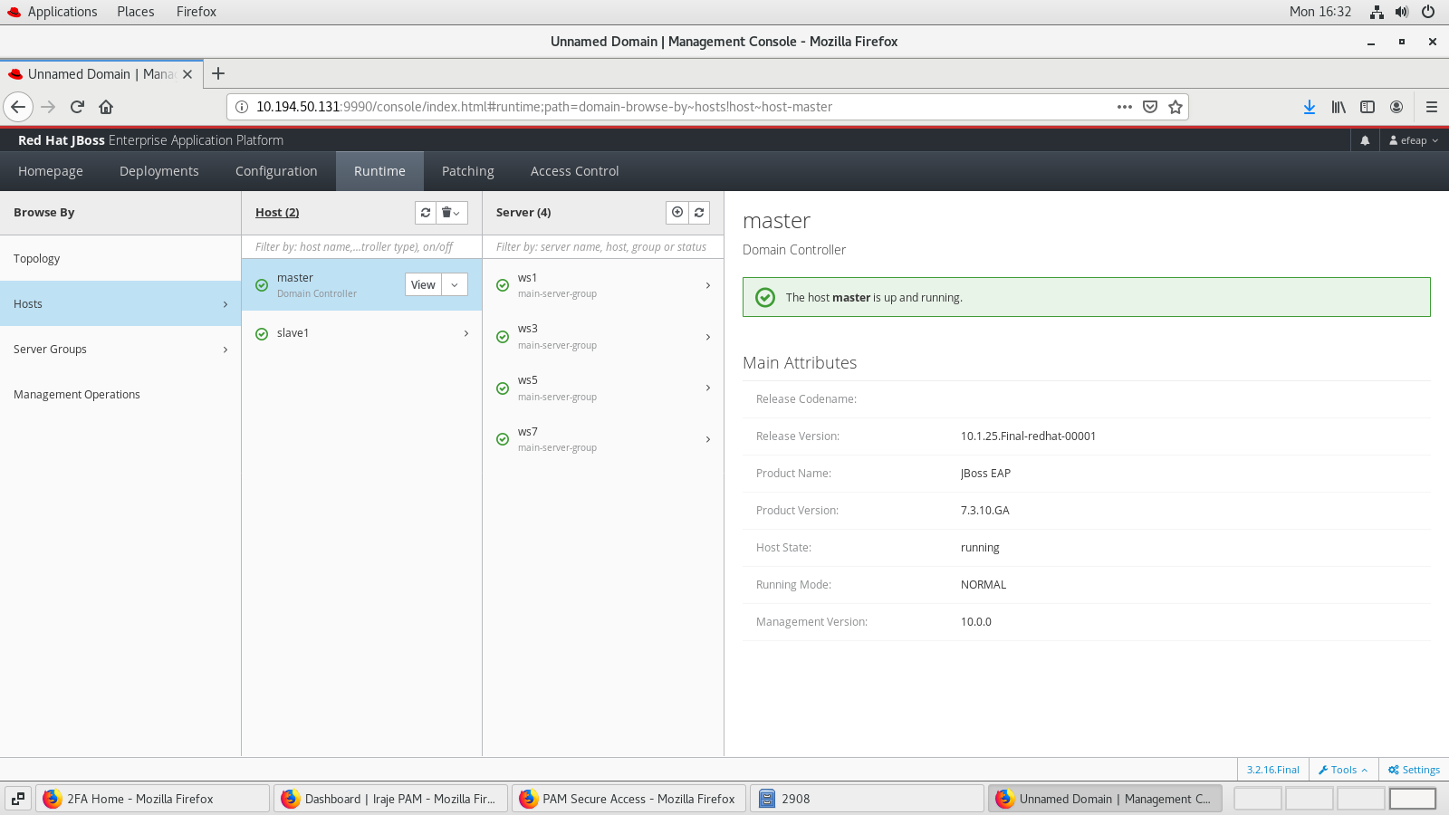

**Nodes and Port number are given like below:**

ws1 – 38080

ws3 – 38090

ws5 – 38070

ws7 – 38060

**Patching JBOSS EAP from 7.3.0 to 7.3.10 in master**

Please find below screenshot for patching in admin console

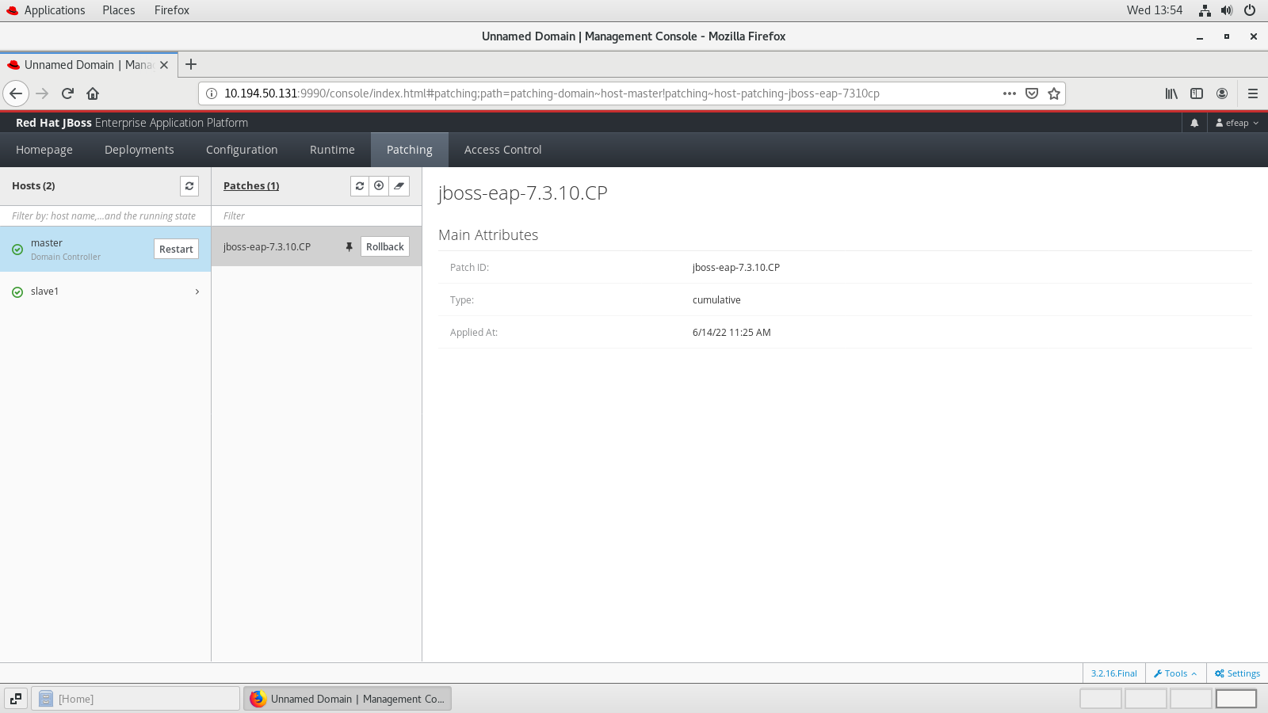

**Database Configuration in WEBA:**

Step1: copy module.xml and mysql connector jar file in below path:

Path: /opt/jboss-eap-7.3/modules/com/mysql/main/

Path: /opt/jboss-eap-7.3/modules/systems/layers/base/com/mysql/main/

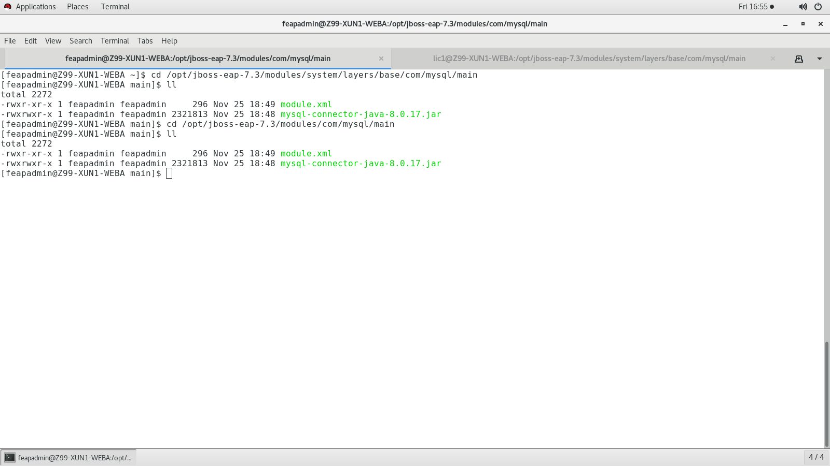

Find below content in module.xml:

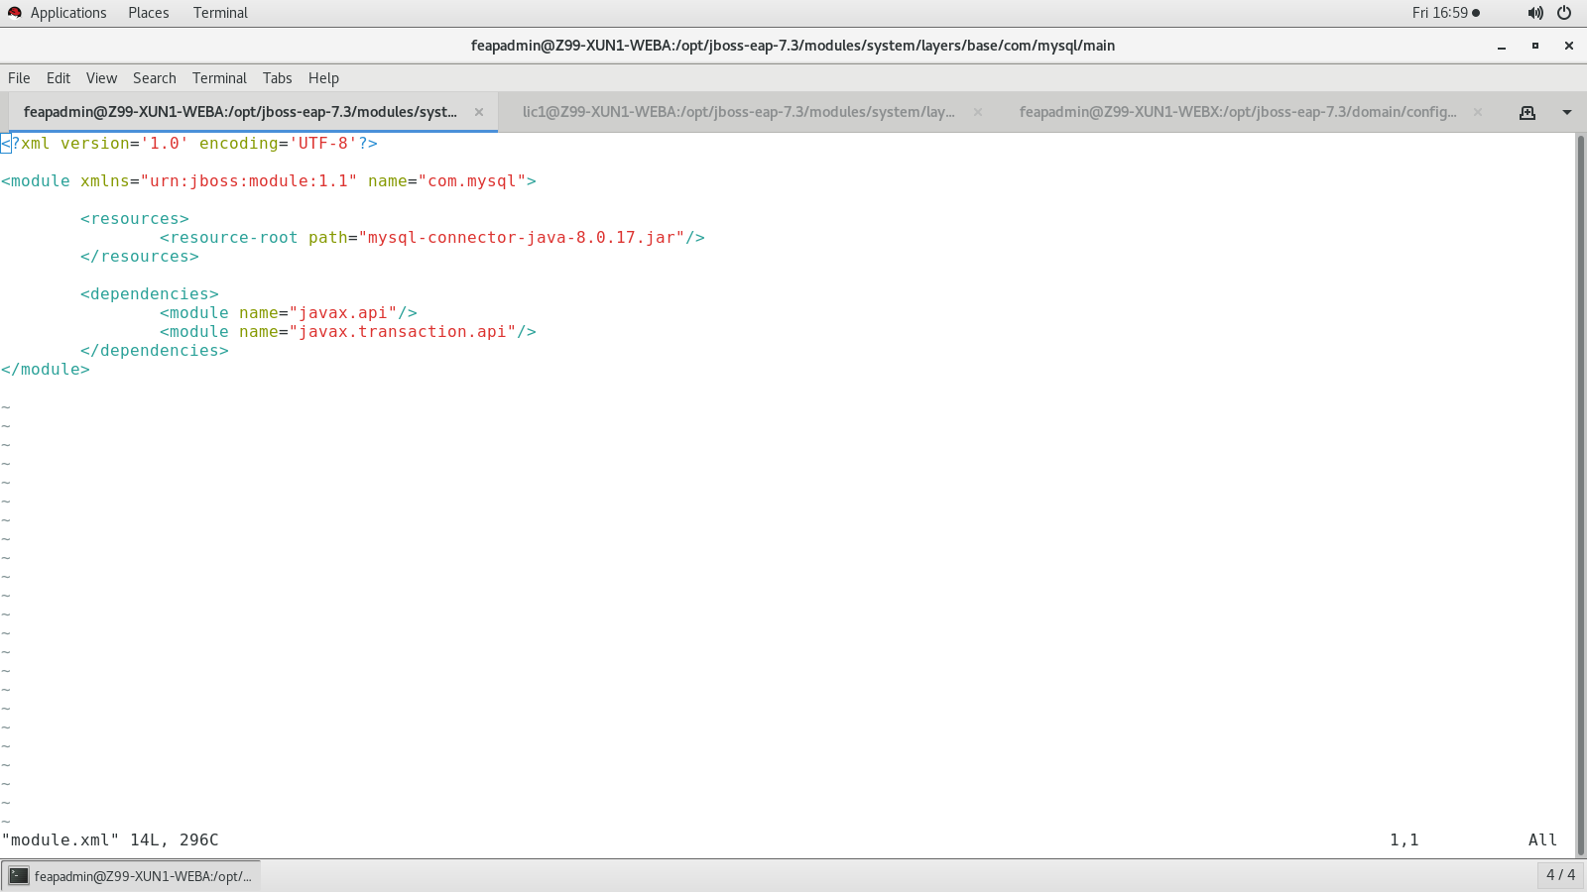

**Step 2:** update the driver and create a data source in domain.xml under **ha** profile like below:

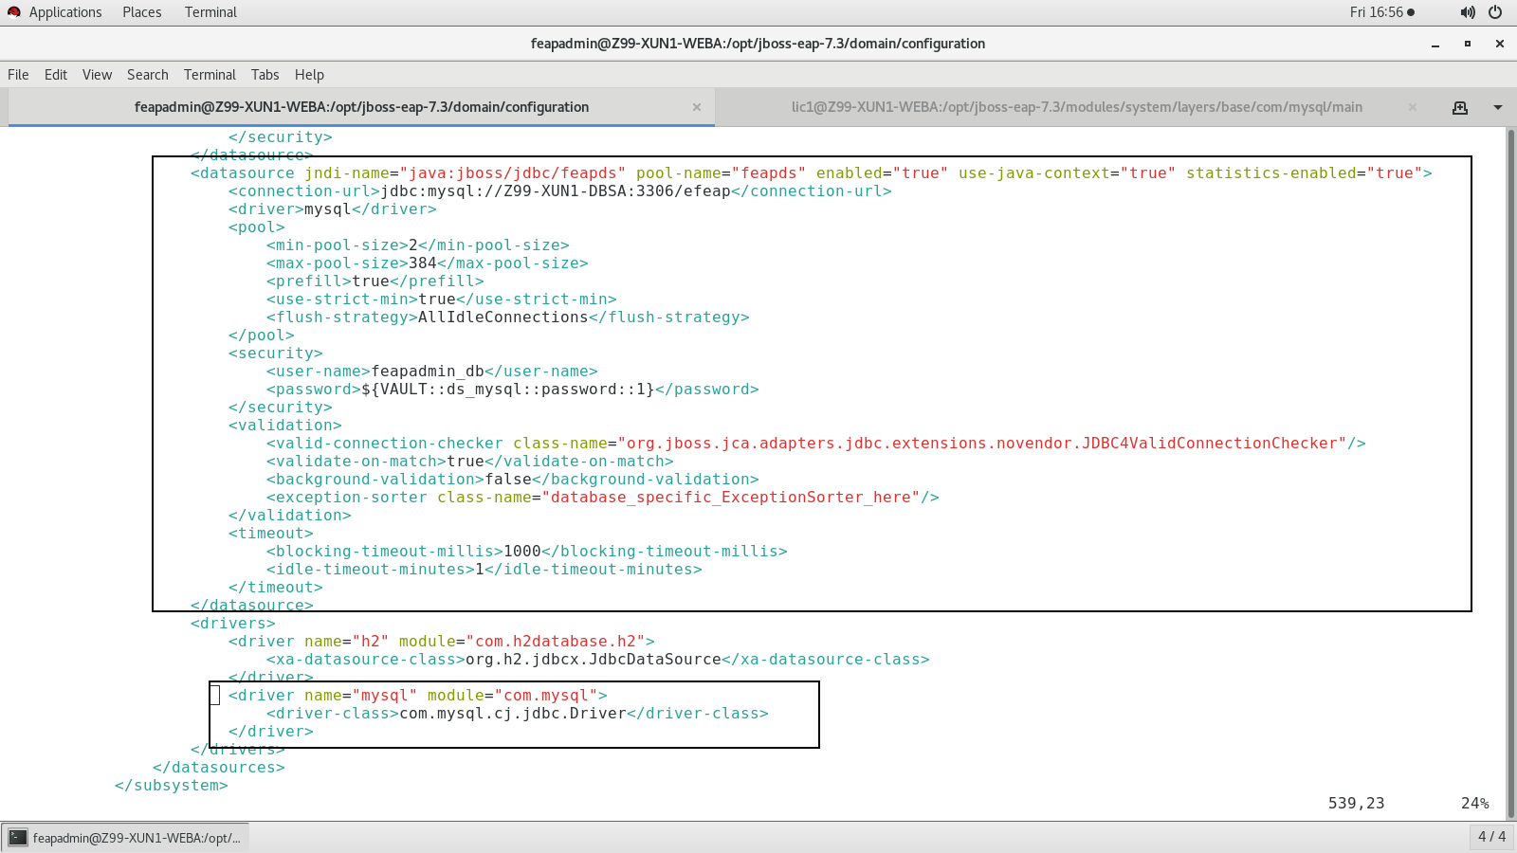

* stop the running jboss process through (**ctrl+c)**

**JBoss starting procedure find below:**

* [feapadmin@WEBA ~]$ cd /opt/jboss-eap-7.3/bin**↵**
* [feapadmin@WEBA bin]$ ./domain.sh --host-config=host-master.xml **↵**

**Step3**: Test database connection in Admin Console:

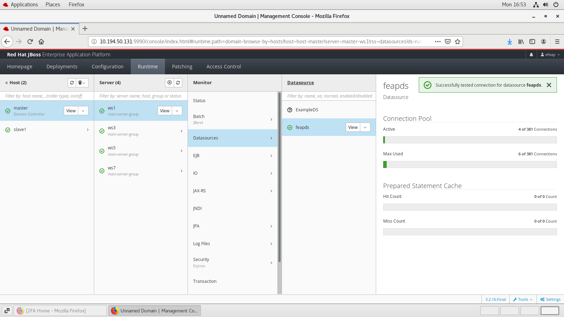

**Adding JBOSS EAP as a service:**

* [feapadmin@WEBA bin]$ cd /opt/jboss-eap-7.3/bin/init.d/**↵**
* [feapadmin@WEBA init.d]$ cp -rv jboss-eap.conf /etc/default/
* [feapadmin@WEBA init.d]$ cp -rv jboss-eap-rhel.sh /etc/init.d/
* [feapadmin@WEBA init.d]$ cd /etc/default/
* [feapadmin@WEBA default]$ vim jboss-eap.conf

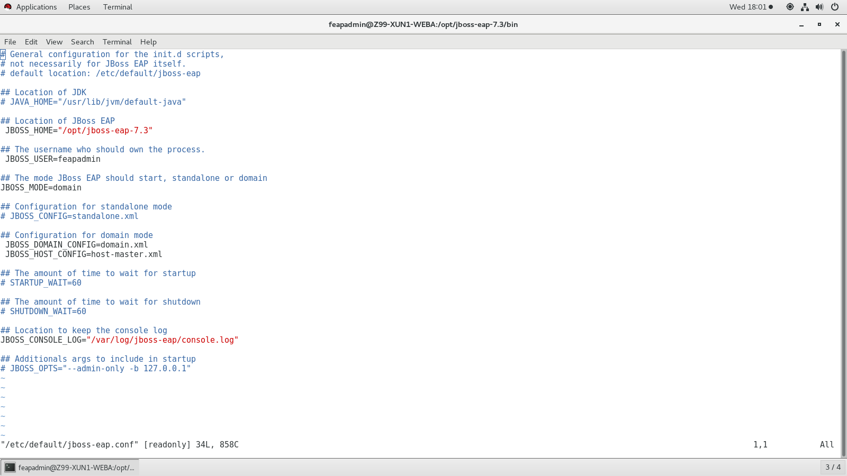

* [feapadmin@WEBA default]$ cd /etc/init.d/
* [feapadmin@WEBA init.d]$ mv jboss-eap-rhel.sh jboss-eap
* [feapadmin@WEBA init.d]$ sudo systemctl enable jboss-eap.service

For starting JBOSS service

* [feapadmin@WEBA init.d]$ sudo systemctl start jboss-eap.service
* [feapadmin@WEBA init.d]$ sudo systemctl status jboss-eap.service

For stopping JBOSS service

* [feapadmin@WEBA init.d]$ sudo systemctl status jboss-eap.service
* [feapadmin@WEBA init.d]$ sudo systemctl stop jboss-eap.service

**Log Files Path:**

Controller Logs:

$ /opt/jboss-eap-7.3/domain/log/host-controller.log

$ /opt/jboss-eap-7.3/domain/log/process-controller.log

Server Logs:

$ /opt/jboss-eap-7.3/domain/servers/ws1/log/server.log

$ /opt/jboss-eap-7.3/domain/servers/ws3/log/server.log

$ /opt/jboss-eap-7.3/domain/servers/ws5/log/server.log

$ /opt/jboss-eap-7.3/domain/servers/ws7/log/server.log

**STEPS TO CREATE PASSWORD VAULT IN ORDER TO ENCRYPT DATABASE PASSWORD IN DATASOURCE:**

1.Create vault folder under /opt/jboss-eap-7.3/vault.

[feapadmin@Z99-XUN1-WEBA jboss]$ mkdir vault

2. Generate vault.keystore in vault directory by using below command

[feapadmin@Z99-XUN1-WEBA vault]$ keytool -genseckey -alias vault -storetype jceks -keyalg AES -keysize 128 -storepass vault@123 -keypass vault@123 -validity 365 -keystore /opt/jboss-eap-7.3/vault/vault.keystore

3.Then, execute below command to store password

Note: Please replace your password highlighted in yellow.

[feapadmin@Z99-XUN1-WEBA vault]$ cd /opt/jboss-eap-7.3/bin

[feapadmin@Z99-XUN1-WEBA bin]$ ./vault.sh --keystore /opt/jboss-eap-7.3/vault/vault.keystore --keystore-password vault@123 --alias vault --vault-block=ds_mysql --attribute password --sec-attr Redhat#123 --enc-dir /opt/jboss-eap-7.3/vault/ --iteration 120 --salt 1234abcd

4.copy VAULT::ds_mysql::password::1 and replace password in domain.xml as ${VAULT::ds_mysql::password::1}

5.Now copy the jboss-cli command and replace the host name as ‘master’ and execute like below to create vault in host-master.xml

[feapadmin@Z99-XUN1-WEBA bin]$ ./jboss-cli.sh -c --controller=10.194.50.131:9990 -u=efeap -p=’efeap’

**Note:** Below sample commands for reference only

[domain@10.194.50.131:9990 /] /host=master/core-service=vault:add(vault-options=[("KEYSTORE_URL" => "/opt/jboss-eap-7.3/vault/vault.keystore"),("KEYSTORE_PASSWORD" => "MASK-2IbZE2xPdI514mIzRrC9GU"),("KEYSTORE_ALIAS" => "vault"),("SALT" => "1234abcd"),("ITERATION_COUNT" => "120"),("ENC_FILE_DIR" => "/opt/jboss-eap-7.3/vault/")])

6.Now restart the WEBA jboss server

Installation instructions for Jboss in WEBB

Log as a root user:

root@WEBB IP:10.194.50.133

* [root@WEBB]# cd /opt**↵**
* [root@WEBB opt]# unzip jboss-eap-7.3.0.zip**↵**
* [[root@ WEBA opt]# chown -R feapadmin:feapadmin jboss-eap-7.3
* [root@WEBA bin]# chmod –R 755 /opt/jboss-eap-7.3 **↵**
* [root@WEBA bin]# su feapadmin

Changes in host-slave.xml file

Path : /opt/jboss-eap-7.3/domain/configuration**↵**Open the file vim host-slave.xml  
  
For more details find the screen shot below.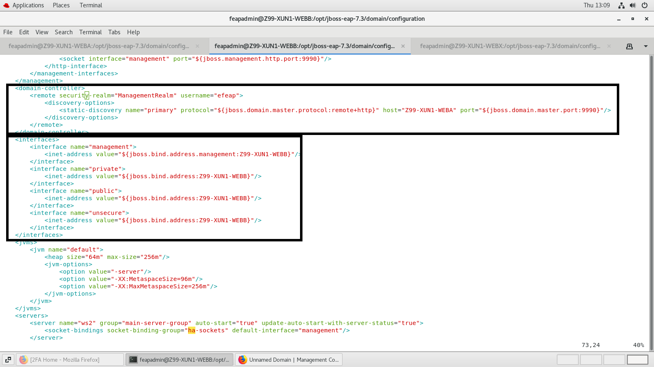

We have added Slave name and we have copied the secret value from master as per screenshot :

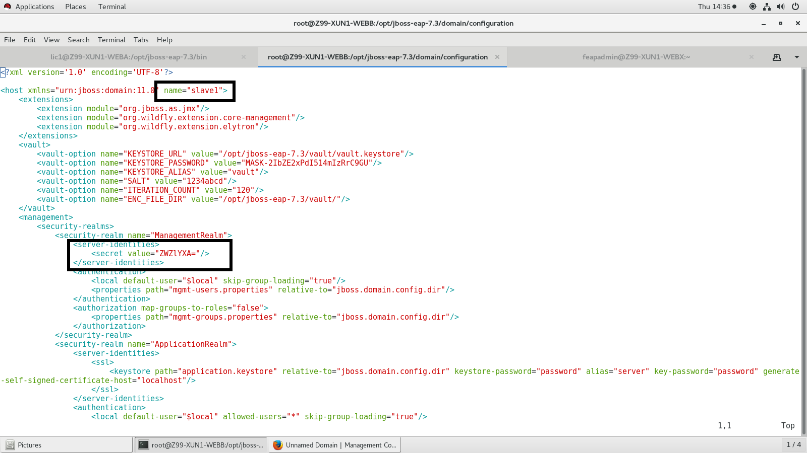

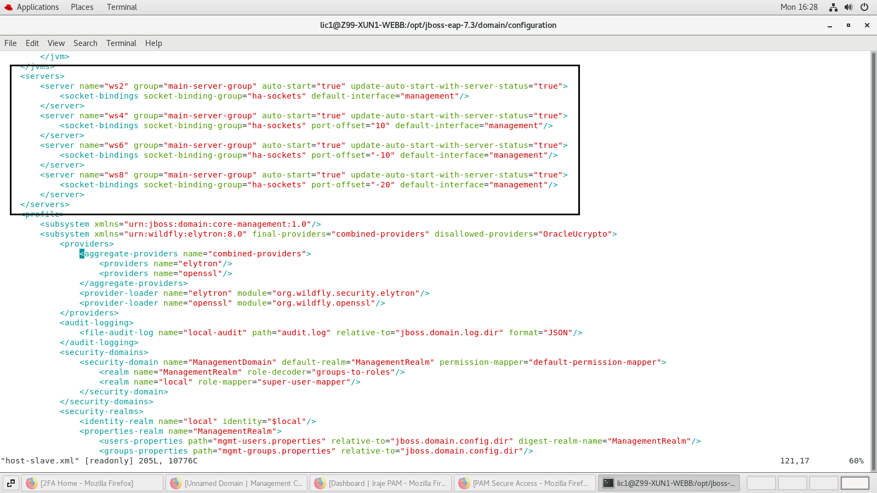

Path: /opt/jboss-eap-7.3/bin

Find below changes in domain.conf file:

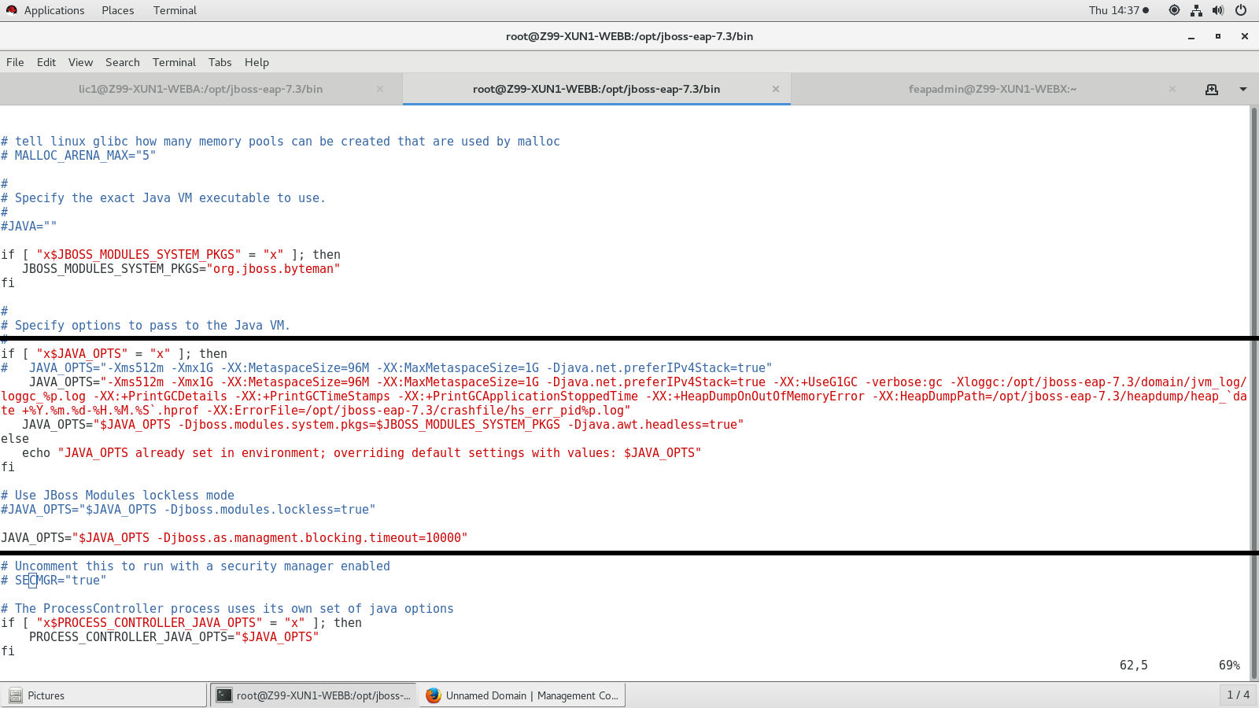

Path for gc log: /opt/jboss-eap-7.3/domain/jvm_log/loggc_%p.log

Path for heapdump: /opt/jboss-eap-7.3/heapdump/heap_`date +%Y.%m.%d-%H.%M.%S`.hprof

Path for crashfile log: /opt/jboss-eap-7.3/crashfile/hs_err_pid%p.log

How to start Jboss in WEBB(Slave)-IP:10.194.50.133:

* [feapadmin@WEBB ~]$ cd /opt/jboss-eap-7.3/bin**↵**
* [feapadmin@WEBB bin]$ ./domain.sh --host-config=host-slave.xml -Djboss.domain.master.address=10.194.50.131 **↵**

**How to Test in Admin Console**

Please find below steps:

* For Testing purpose Open Firefox and type in url http://10.194.50.131:9990/console/index.html
* Enter Username and password and click on Ok

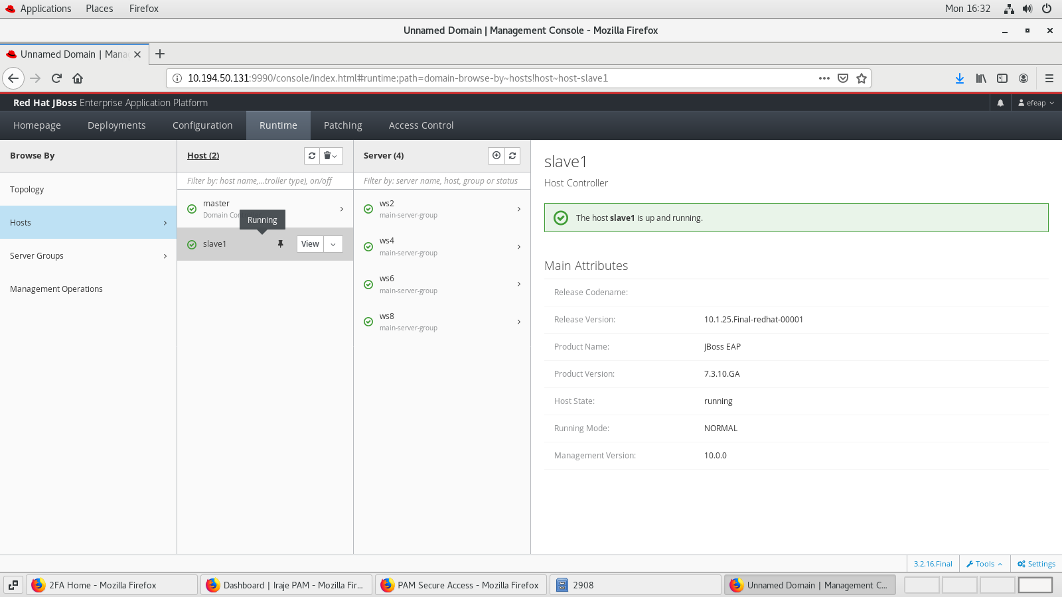

**Nodes and Port number are given like below:**

ws2 – 38080

ws4 – 38090

ws6 – 38070

ws8 – 38060

**Test database connection in Admin Console:**

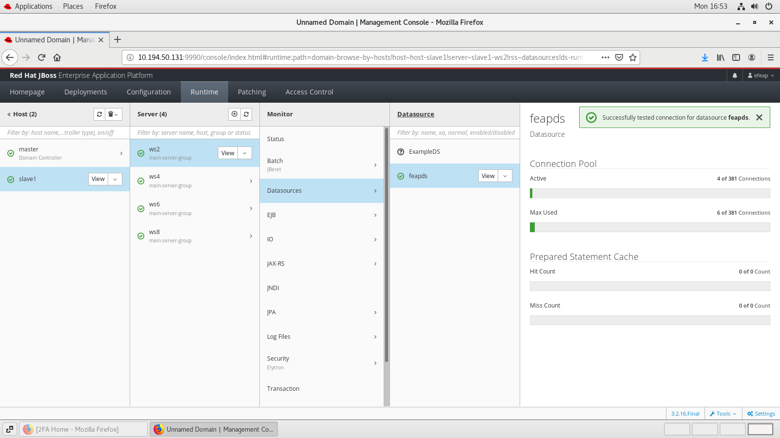

**Patching JBOSS EAP from 7.3.0 to 7.3.10 in slave1**

Please find below screenshot for patching in admin console

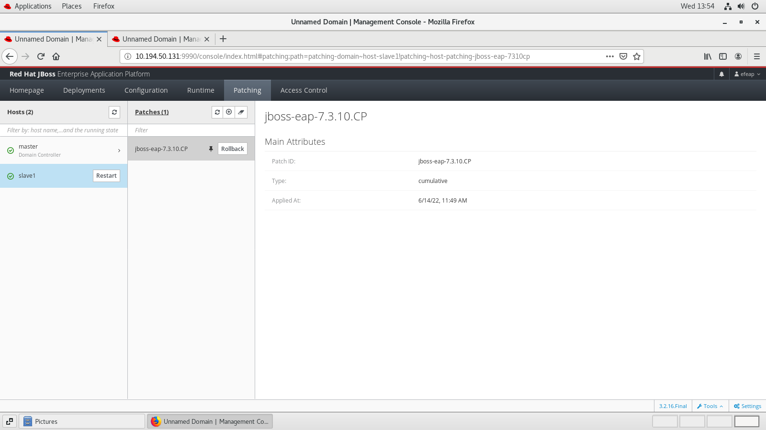

**Adding JBOSS EAP as a service**

* [feapadmin@WEBB bin]$ cd /opt/jboss-eap-7.3/bin/init.d/**↵**
* [feapadmin@WEBB init.d]$ cp -rv jboss-eap.conf /etc/default/
* [feapadmin@WEBB init.d]$ cp -rv jboss-eap-rhel.sh /etc/init.d/
* [feapadmin@WEBB init.d]$ cd /etc/default/
* [feapadmin@WEBB default]$ vim jboss-eap.conf

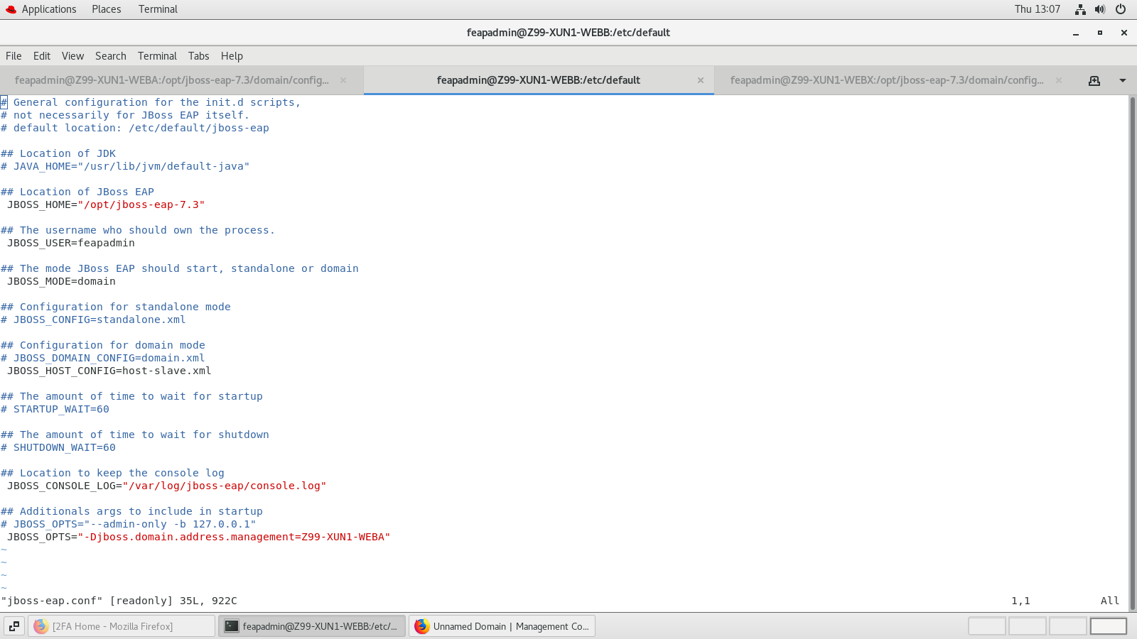

* [feapadmin@WEBB default]$ cd /etc/init.d/
* [feapadmin@WEBB init.d]$ mv jboss-eap-rhel.sh jboss-eap
* [feapadmin@WEBB init.d]$ sudo systemctl enable jboss-eap.service

For starting JBOSS service

* [feapadmin@WEBB init.d]$ sudo systemctl start jboss-eap.service
* [feapadmin@WEBB init.d]$ sudo systemctl status jboss-eap.service

For stopping JBOSS service

* [feapadmin@WEBB init.d]$ sudo systemctl status jboss-eap.service
* [feapadmin@WEBB init.d]$ sudo systemctl stop jboss-eap.service

**Log Files Path:**

Controller Logs:

$ /opt/jboss-eap-7.3/domain/log/host-controller.log

$ /opt/jboss-eap-7.3/domain/log/process-controller.log

Server Logs:

$ /opt/jboss-eap-7.3/domain/servers/ws2/log/server.log

$ /opt/jboss-eap-7.3/domain/servers/ws4/log/server.log

$ /opt/jboss-eap-7.3/domain/servers/ws6/log/server.log

$ /opt/jboss-eap-7.3/domain/servers/ws8/log/server.log

**STEPS TO CREATE PASSWORD VAULT IN ORDER TO ENCRYPT DATABASE PASSWORD IN DATASOURCE:**

1.Create vault folder under /opt/jboss-eap-7.3/vault.

[feapadmin@Z99-XUN1-WEBB jboss]$ mkdir vault

2. Generate vault.keystore in vault directory by using below command

[feapadmin@Z99-XUN1-WEBB vault]$ keytool -genseckey -alias vault -storetype jceks -keyalg AES -keysize 128 -storepass vault@123 -keypass vault@123 -validity 365 -keystore /opt/jboss-eap-7.3/vault/vault.keystore

3.Then, execute below command to store password

Note: Please replace your password highlighted in yellow.

[feapadmin@Z99-XUN1-WEBB vault]$ cd /opt/jboss-eap-7.3/bin

[feapadmin@Z99-XUN1-WEBB bin]$ ./vault.sh --keystore /opt/jboss-eap-7.3/vault/vault.keystore --keystore-password vault@123 --alias vault --vault-block=ds_mysql --attribute password --sec-attr Redhat#123 --enc-dir /opt/jboss-eap-7.3/vault/ --iteration 120 --salt 1234abcd

4.Now copy the jboss-cli command and replace the host name as ‘slave1’ and execute like below to create vault in host-slave.xml

[feapadmin@Z99-XUN1-WEBB bin]$ ./jboss-cli.sh -c --controller=10.194.50.133:9990 -u=efeap -p=efeap

**Note:** Below sample commands for reference only

[domain@10.194.50.133:9990 /] /host=slave1/core-service=vault:add(vault-options=[("KEYSTORE_URL" => "/opt/jboss-eap-7.3/vault/vault.keystore"),("KEYSTORE_PASSWORD" => "MASK-2IbZE2xPdI514mIzRrC9GU"),("KEYSTORE_ALIAS" => "vault"),("SALT" => "1234abcd"),("ITERATION_COUNT" => "120"),("ENC_FILE_DIR" => "/opt/jboss-eap-7.3/vault/")])

6.Now restart the WEBB jboss server

Installation instructions for JBOSS inWEBX

Log as a root user:

root@WEBX IP:10.194.50.151 (WEBX_Master)

* [root@WEBX]# cd /opt**↵**
* [root@WEBX opt]# unzip jboss-eap-7.3.0.zip**↵**
* [root@WEBX opt]# chown -R feapadmin:feapadmin jboss-eap-7.3
* [root@WEBX bin]# chmod –R 755 /opt/jboss-eap-7.3 **↵**
* [root@WEBX bin]# su feapadmin
* [feapadmin@WEBX bin]$ cd /opt/jboss-eap-7.3/bin**↵**
* [feapadmin@WEBX bin]$ ./add-user.sh**↵**
* Press **a** for Management user
* Enter username as **efeap**

**If efeap is already exist then press “ a “ for update**

* Enter password as **efeap**
* Are you sure you want to use the password entered yes/no? – yes
* Re-enter Password **efeap**
* What groups do you want this user to belong to? – Press Enter
* Is this correct yes/no? – yes
* e.g. for a slave host controller connecting to the master – yes

Path: /opt/jboss-eap-7.3/domain/configuration

Changes done in host-master.xml file like below:

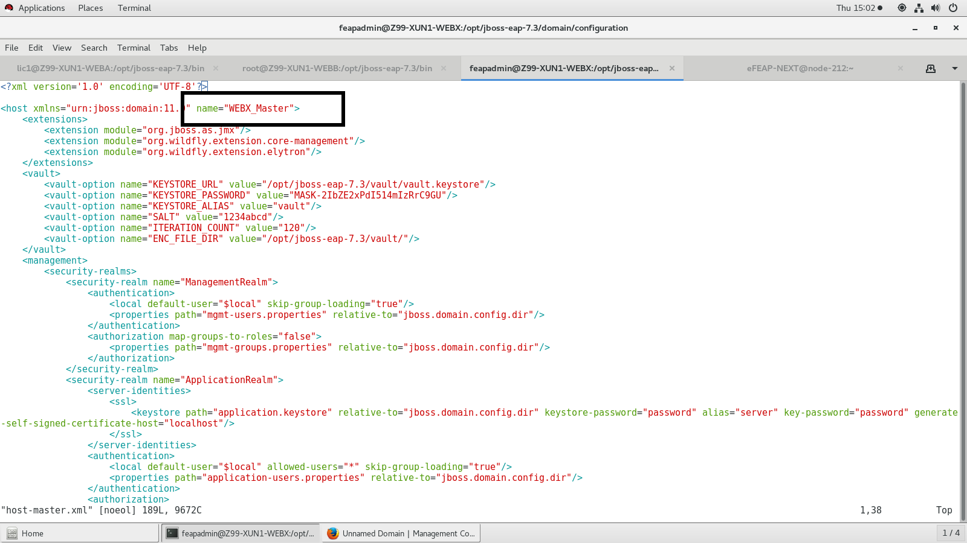

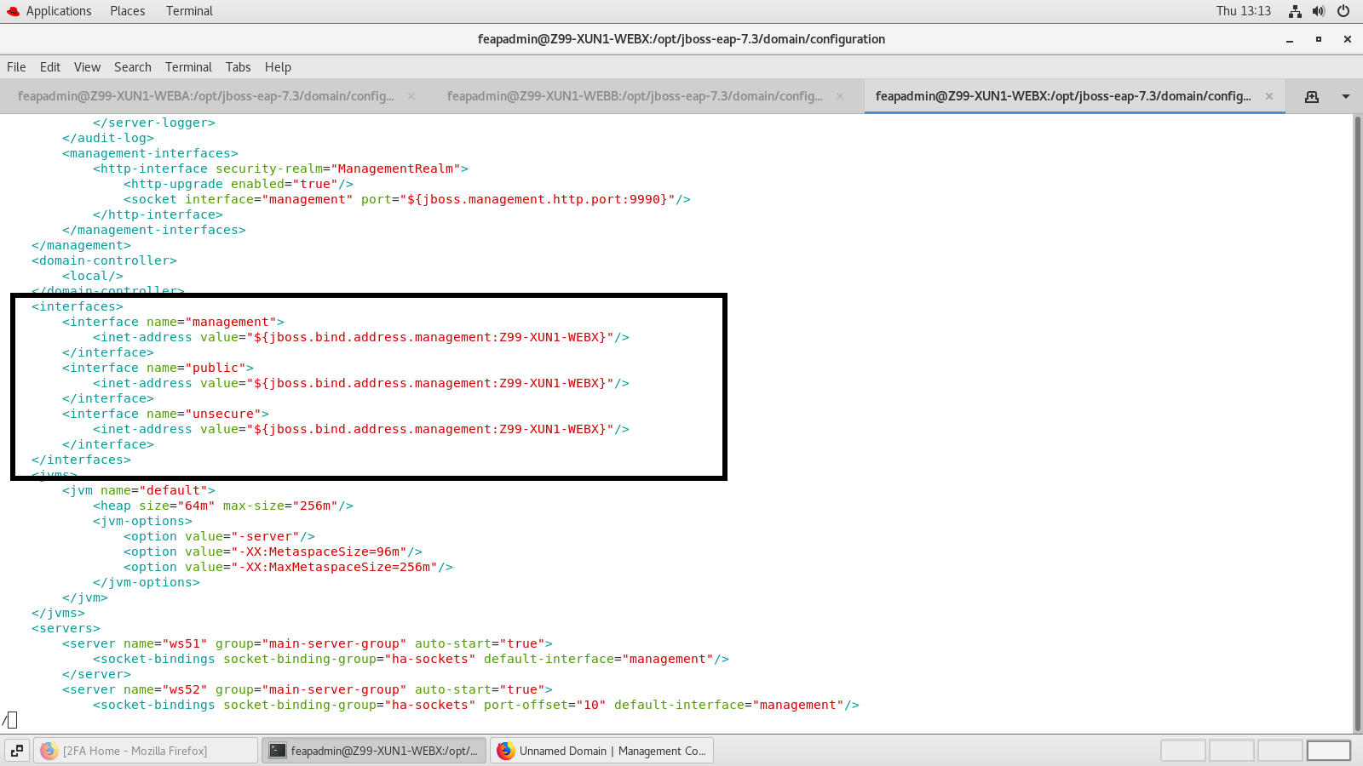

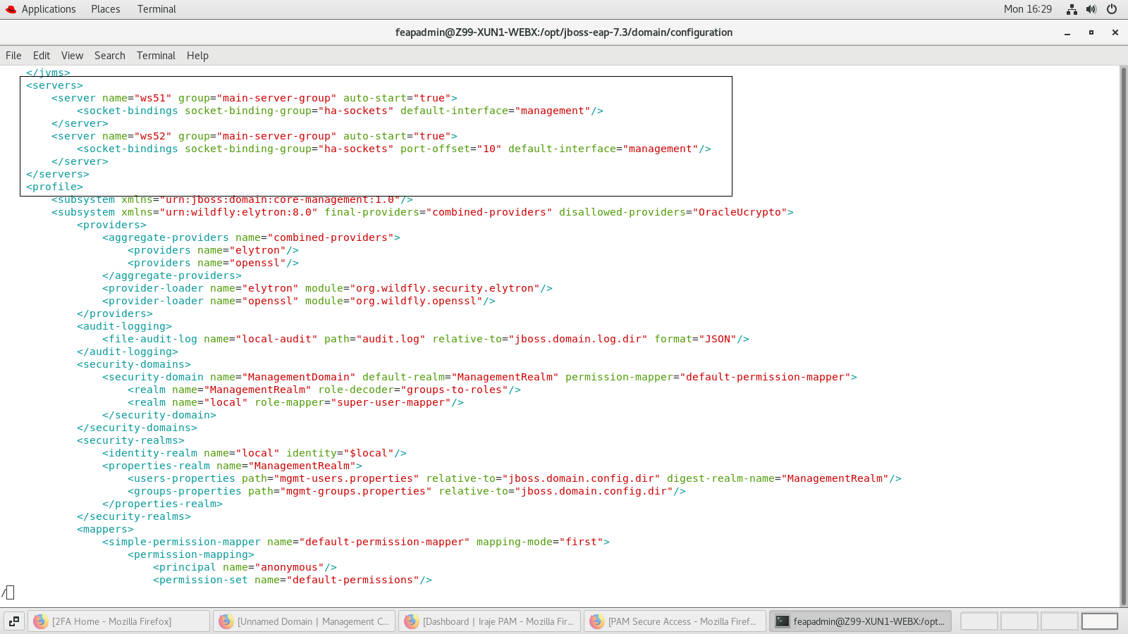

Add security domain under **ha** profile and heap size under server groups in domain.xml like below:

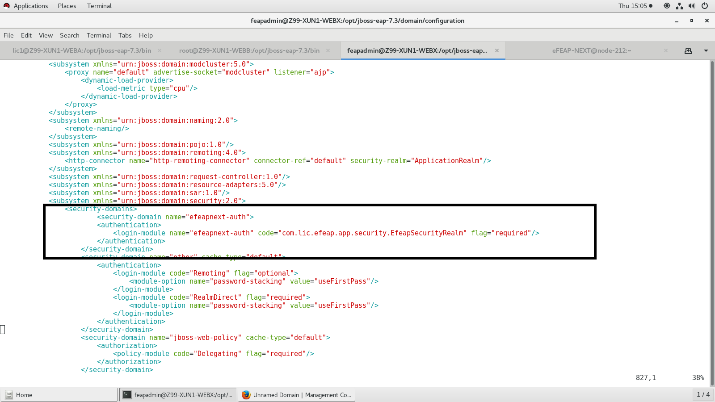

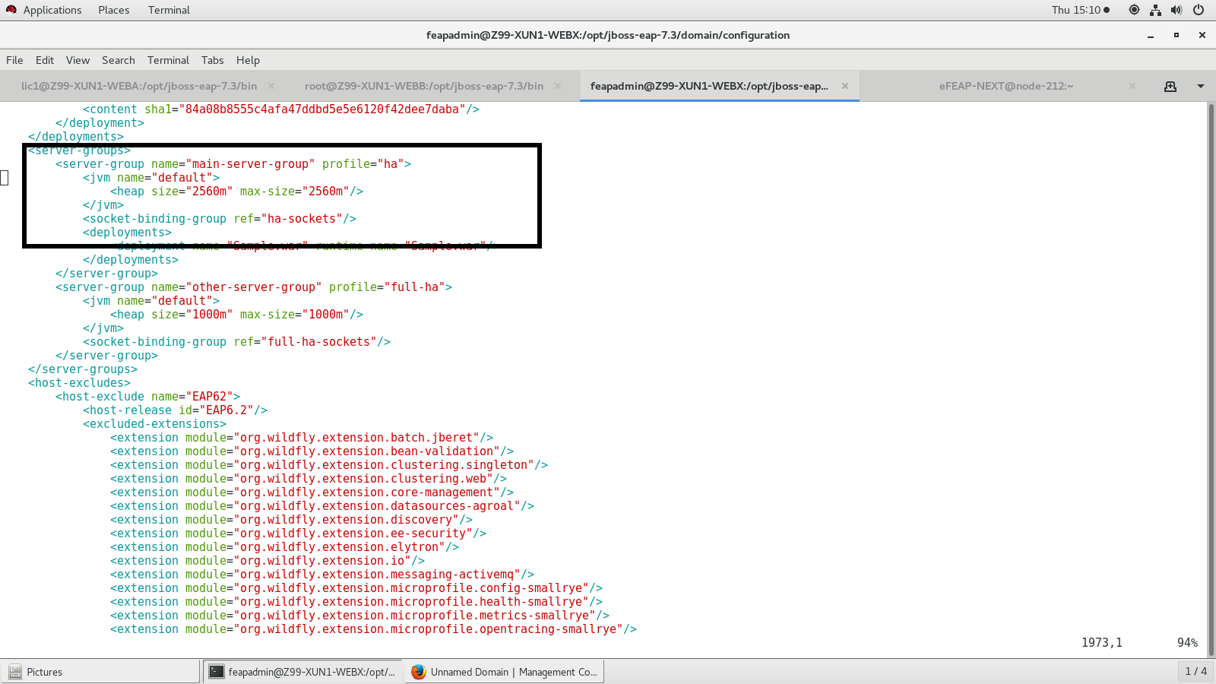

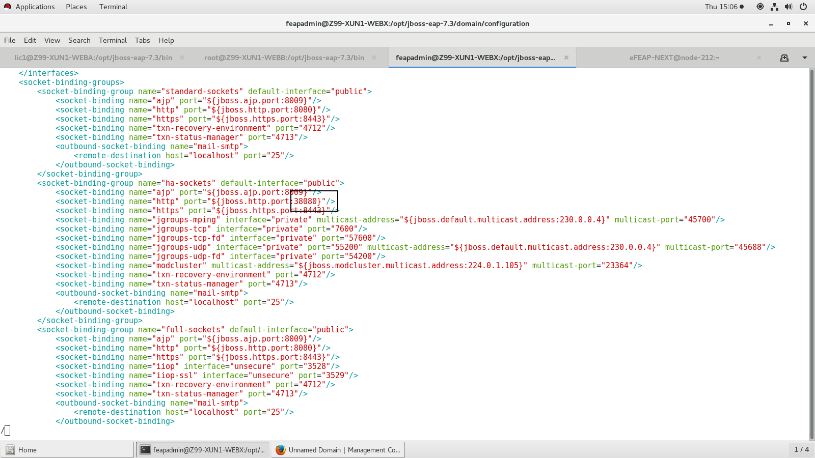

Path: [feapadmin@WEBA bin]$ /opt/jboss-eap-7.3/bin/

Find below changes in domain.conf file:

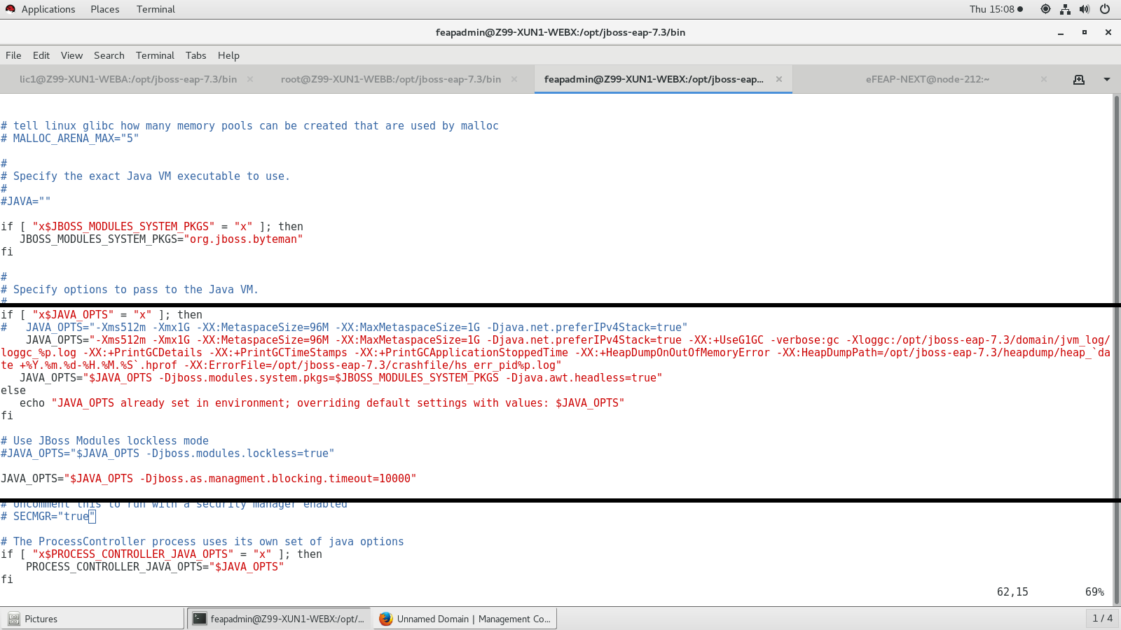

Path for gc log: /opt/jboss-eap-7.3/domain/jvm_log/loggc_%p.log

Path for heapdump: /opt/jboss-eap-7.3/heapdump/heap_`date +%Y.%m.%d-%H.%M.%S`.hprof

Path for crashfile log: /opt/jboss-eap-7.3/crashfile/hs_err_pid%p.log

**JBoss starting procedure find below:**

* [feapadmin@WEBA ~]$ cd /opt/jboss-eap-7.3/bin**↵**
* [feapadmin@WEBA bin]$ ./domain.sh --host-config=host-master.xml **↵**
* For Testing purpose Open Firefox and type in url http://10.194.50.131:9990/console/index.html
* Enter Username and password and click on Ok

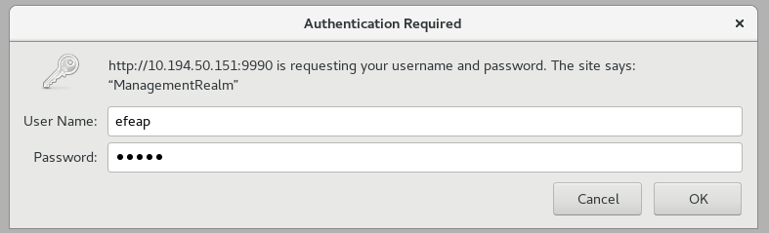

* Close firefox and stop the running jboss process through (**ctrl+c)**

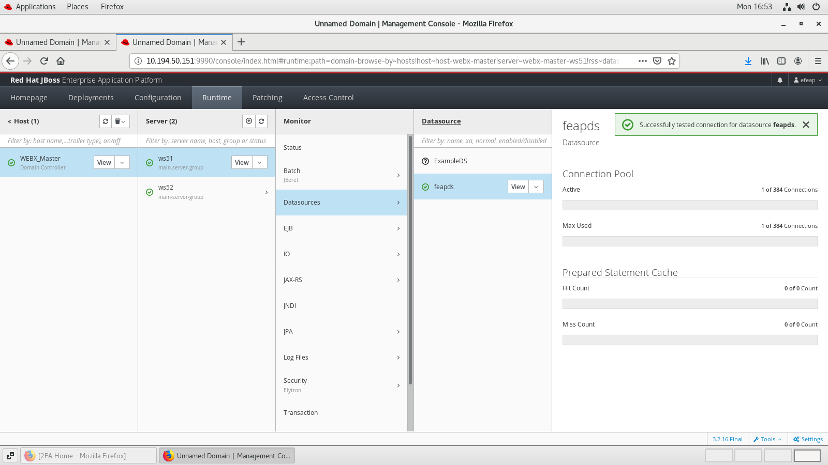

Port Number have given below:

ws51 – 38080

ws52 – 38090

**Patching JBOSS EAP from 7.3.0 to 7.3.10 in WEBX_Master**

Please find below screenshot for patching in admin console

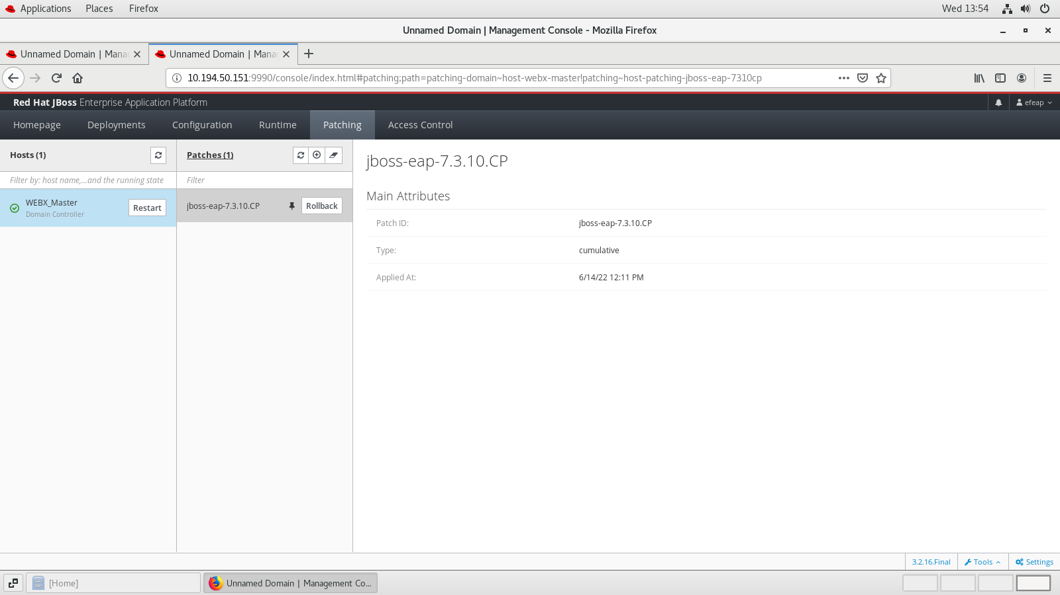

**Database Configuration in WEBX:**

Step1: copy module.xml and mysql connector jar file in below path:

Path: /opt/jboss-eap-7.3/modules/com/mysql/main/

Path: /opt/jboss-eap-7.3/modules/systems/layers/base/com/mysql/main/

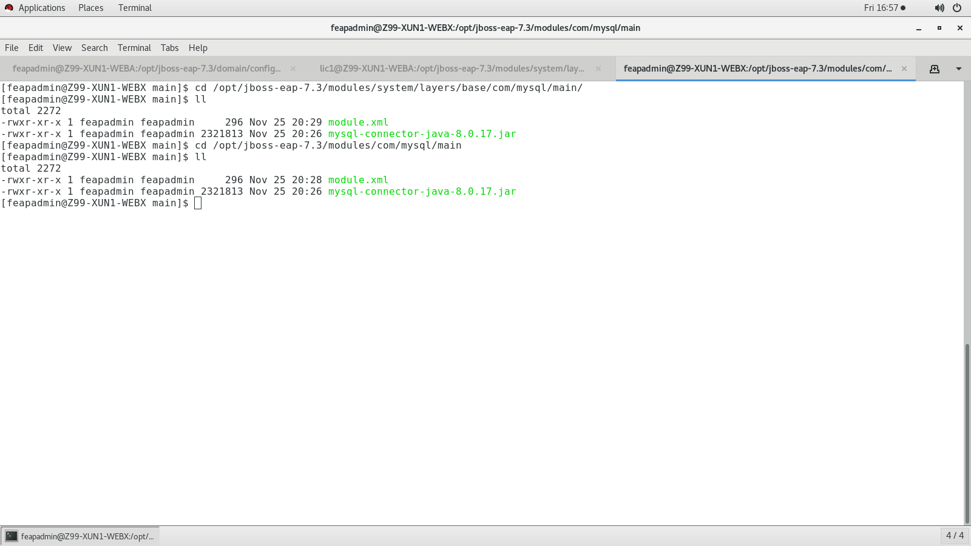

Find below content in module.xml:



**Step 2:** update the driver and create a datasource in domain.xml under **ha** profile like below:

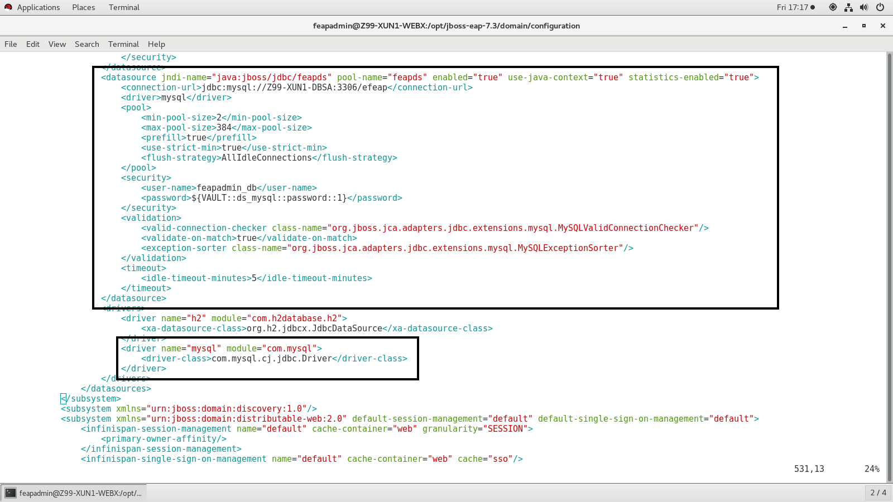

**Step3**: Test database connection in Admin Console:



**Adding JBOSS EAP as a service:**

* [feapadmin@WEBX bin]$ cd /opt/jboss-eap-7.3/bin/init.d/**↵**
* [feapadmin@WEBX init.d]$ cp -rv jboss-eap.conf /etc/default/
* [feapadmin@WEBX init.d]$ cp -rv jboss-eap-rhel.sh /etc/init.d/
* [feapadmin@WEBX init.d]$ cd /etc/default/
* [feapadmin@WEBX default]$ vim jboss-eap.conf

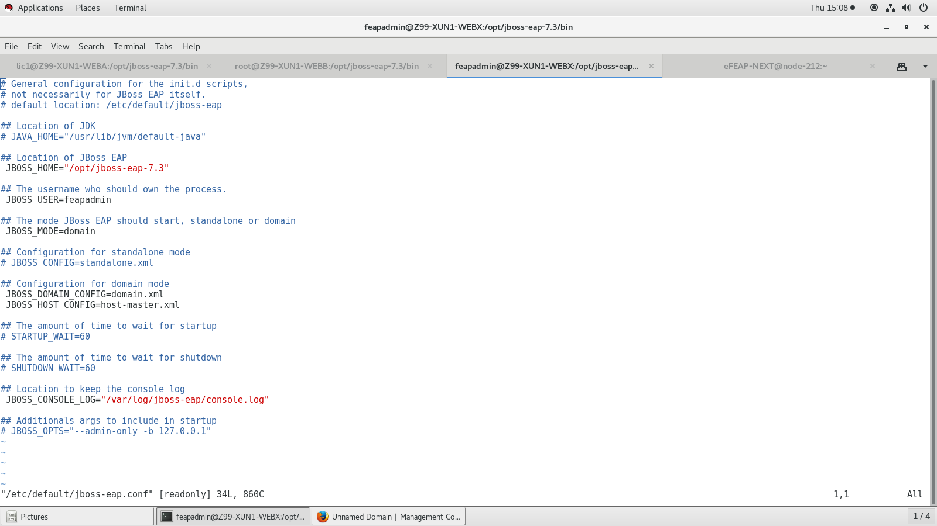

* [feapadmin@WEBX default]$ cd /etc/init.d/
* [feapadmin@WEBX init.d]$ mv jboss-eap-rhel.sh jboss-eap
* [feapadmin@WEBX init.d]$ sudo systemctl enable jboss-eap.service

For starting JBOSS service

* [feapadmin@WEBX init.d]$ sudo systemctl start jboss-eap.service
* [feapadmin@WEBX init.d]$ sudo systemctl status jboss-eap.service

For stopping JBOSS service

* [feapadmin@WEBX init.d]$ sudo systemctl status jboss-eap.service
* [feapadmin@WEBX init.d]$ sudo systemctl stop jboss-eap.service

**Log Files Path:**

Controller Logs:

$ /opt/jboss-eap-7.3/domain/log/host-controller.log

$ /opt/jboss-eap-7.3/domain/log/process-controller.log

Server Logs:

$ /opt/jboss-eap-7.3/domain/servers/ws51/log/server.log

$ /opt/jboss-eap-7.3/domain/servers/ws52/log/server.log

**STEPS TO CREATE PASSWORD VAULT IN ORDER TO ENCRYPT DATABASE PASSWORD IN DATASOURCE:**

1.Create vault folder under /opt/jboss-eap-7.3/vault.

[feapadmin@Z99-XUN1-WEBX jboss]$ mkdir vault

2. Generate vault.keystore in vault directory by using below command

[feapadmin@Z99-XUN1-WEBX vault]$ keytool -genseckey -alias vault -storetype jceks -keyalg AES -keysize 128 -storepass vault@123 -keypass vault@123 -validity 365 -keystore /opt/jboss-eap-7.3/vault/vault.keystore

3.Then, execute below command to store password

Note: Please replace your password highlighted in yellow.

[feapadmin@Z99-XUN1-WEBX vault]$ cd /opt/jboss-eap-7.3/bin

[feapadmin@Z99-XUN1-WEBX bin]$ ./vault.sh --keystore /opt/jboss-eap-7.3/vault/vault.keystore --keystore-password vault@123 --alias vault --vault-block=ds_mysql --attribute password --sec-attr Redhat#123 --enc-dir /opt/jboss-eap-7.3/vault/ --iteration 120 --salt 1234abcd

4.copy VAULT::ds_mysql::password::1 and replace password in domain.xml as ${VAULT::ds_mysql::password::1}